**Walmart Sales Analysis 2024**

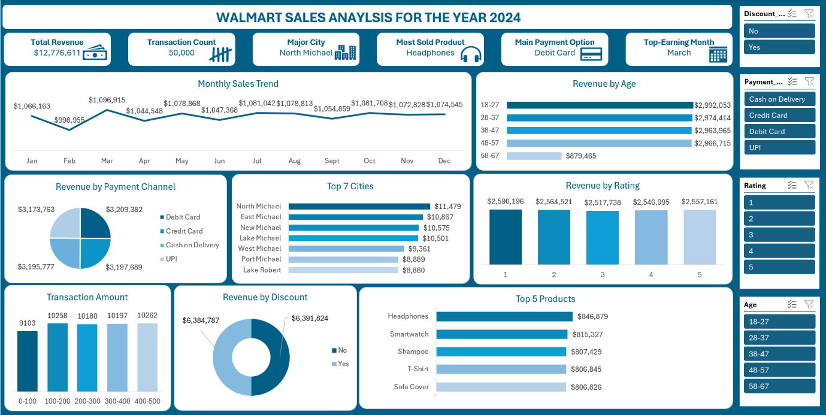

**INTRODUCTION**

Walmart is a global retail giant offering a diverse range of products, including electronics, clothing, home essentials, and groceries. This analysis delves into customer shopping behaviours, revenue distribution, and key trends across Walmart locations in 2024. By examining sales data(including age groups, payment methods, product categories, and city-wise performance)this study aims to uncover hidden purchasing patterns. These insights will help Walmart refine its product offerings, optimize store strategies, and improve customer satisfaction.

**PROBLEM STATEMENT**

Walmart seeks to understand its customers' shopping preferences to enhance sales performance and overall customer experience. With numerous product categories and store locations, identifying top-performing segments and optimizing inventory management is a challenge.

This analysis identifies key purchase patterns, including high-demand products, demographic-driven buying behaviours, and preferred payment methods. These insights will guide Walmart in making data-driven decisions to improve marketing strategies, streamline payment options, and boost sales.

**OBJECTIVES**

The primary goal of this analysis is to extract actionable insights from Walmart’s 2024 sales data. Specifically, we aim to:

1. **Identify Best-Selling Products:** Determine which product categories drive the highest revenue.
2. **Analyze Customer Demographics:** Understand how age groups influence purchasing decisions.
3. **Evaluate Store Performance by Location:** Identify high-performing cities and regions.
4. **Assess Payment Preferences:** Discover the most preferred payment methods to streamline transactions.
5. **Optimize Discount Strategies:** Analyze the impact of discounts on total revenue and profitability.

**DATA OVERVIEW**

**Data Source**

The dataset was downloaded from [Kaggle](https://www.kaggle.com/).

Tool Used: Excel was used for data cleaning, analysis and dashboard creation.

**Cleaned Dataset**

The dataset contains detailed transaction records, including:

**Independent Values**

Customer_ID: Unique identifier (helps in tracking records).

Age: Customer’s age.

Gender: Customer's gender.

City: Location of the customer.

Category: Type of product purchased.

Product_Name: Specific product purchased.

Purchase_Date: Date of purchase.

Payment_Method: Mode of payment (e.g., credit card, debit card, cash, etc.).

Discount_Applied: Whether a discount was applied or not.

**Dependent Values**

These are the outcomes influenced by the independent variables:

Purchase_Amount: Total amount spent (can be predicted based on factors like age, city, category, discount, etc.).

Rating: Customer's rating of the product.

Repeat_Customer: Whether the customer made a repeat purchase.

**DATA CLEANING**

To ensure data accuracy, the following steps were taken:

* Duplicate Removal: Checked for and removed duplicate transactions.
* Missing Value Handling: Ensured key fields (Customer ID, Revenue, Payment Method) had no null values.
* Data Standardization: Formatted text fields for consistency (e.g., standardized Revenue).

**DATA ANALYSIS**

**KPIs**

The following KPIs were analysed to understand Walmart’s 2024 performance:

1. **Total Revenue:** Walmart's total revenue in 2024 stands at **$12.78 million**, reflecting overall sales across all locations and product categories.
2. **Total Transactions**: The total number of recorded sales transactions is **50,000** across all Walmart locations. This metric provides insight into customer purchase frequency and transaction volume.
3. **Top-Earning Month:** **March** generated the highest revenue at $1.97 million, making it the most profitable month of 2024.
4. **Major City:** North Michael contributed the highest revenue among all cities, with $11,479 in sales.
5. **Most Sold Product:** Headphones emerged as the top-selling product, generating $846,879 in revenue.
6. **Main Payment Option:** The most used payment method was **debit cards**, accounting for $3,209,382 in transactions.

**BEST-SELLING PRODUCTS**

The top five highest-selling products:

* Headphones: $846,879
* Smartwatch: $815,327
* Shampoo: $807,429
* T-Shirt: $806,845
* Sofa Cover: $806,826

**REVENUE BREAKDOWN BY CUSTOMER DEMOGRAPHICS**

Purchases by Age Group:

* 18-27: $2,992,053 (Highest revenue-generating group)
* 28-37: $2,974,414
* 38-47: $2,963,965
* 48-57: $2,966,715
* 58-67: $879,465 (Lowest revenue group)

**REVENUE BY STORE LOCATION**

Top five cities contributing to Walmart’s revenue:

* North Michael: $11,479 (Highest revenue city)
* East Michael: $10,867
* New Michael: $10,575
* Lake Michael: $10,501
* West Michael: $9,361

**PAYMENT PREFERENCES**

Preferred payment methods based on total revenue:

* Debit Card: $3,209,382 (Most used payment method)
* Credit Card: $3,197,689
* Cash on Delivery: $3,195,777
* UPI: $3,173,763

**DISCOUNT IMPACT ON SALES**

* With Discount: $6,384,787
* Without Discount: $6,391,824

The revenue generated by discounted and non-discounted sales suggests that discounts are not the sole driver of purchases.

INSIGHTS

Based on the data, the following key insights were derived: Younger Customers (18–37) drove the most sales: This age group generated the highest revenue, showing that marketing campaigns should target younger consumers.

North Michael, East Michael, and New Michael are the top revenue Contributors: Walmart should focus on inventory management and promotional efforts in these high-performing cities.

Electronics and Personal Care Products Lead Sales: Headphones and smartwatches are the top-selling products, indicating that there is high demand for tech items.

Debit Cards are the most preferred payment method: Walmart should devise means of insuring seamless debit card transactions as this can enhance the customer experience.

Discounts Do Not Heavily Impact Revenue: With and without discount sales in Walmart stores are nearly equal, showing that Walmart should evaluate whether discounting strategies are necessary.

RECOMMENDATIONS

Walmart should enhance targeted marketing for younger customers (18–37) by Investing in digital marketing campaigns on social media platforms to reach younger demographics. Offering loyalty programs and exclusive promotions tailored to this age group. Featuring trending products (e.g., smartwatches, headphones) prominently in online and offline advertisements.

Expand and Optimize High-Performing Store Locations through Increasing inventory levels and introducing localized promotions in North Michael, East Michael, and New Michael.

Evaluating the feasibility of opening new stores in similar high-demand areas.

Improve customer experience in these cities through better staffing, faster checkout processes, and personalized services.

Capitalize on Electronics and Personal Care Demand by Expanding product lines in the electronics and personal care categories. Offering bundling discounts (e.g., smartwatches + headphones) to boost cross-selling. Collaborating with popular tech brands for exclusive deals and new product launches.

Streamline Payment Experiences with Debit Card Transactions Ensure seamless debit card transactions by improving payment infrastructure. Partnering with banks to offer cashback or reward points for debit card purchases. Promote digital wallets linked to debit cards for faster checkouts.

Reevaluate Discount Strategies: Since discounts have no significant impact on overall revenue generated, Walmart should focus on value-driven promotions (e.g., bundle deals, loyalty rewards) rather than direct price reductions. Implement personalized discount offers based on customer purchase history. Experiment with targeted discounts for low-revenue age groups (e.g., 58–67) to boost their engagement.

CONCLUSION

The 2024 Walmart sales analysis reveals important trends in customer behaviour, payment preferences, and product demand. By leveraging on these insights, Walmart can refine its marketing strategies, optimize store performance, and enhance customer engagement for continued growth.